6.1 Functions and Systems of Equations in Two Variables

Motivation: Before, we were solving a single equation with 1 variable. Now, we're solving a system of equations with 2 equations and 2 unknown variables. Key Idea: The solution is the intersection point.

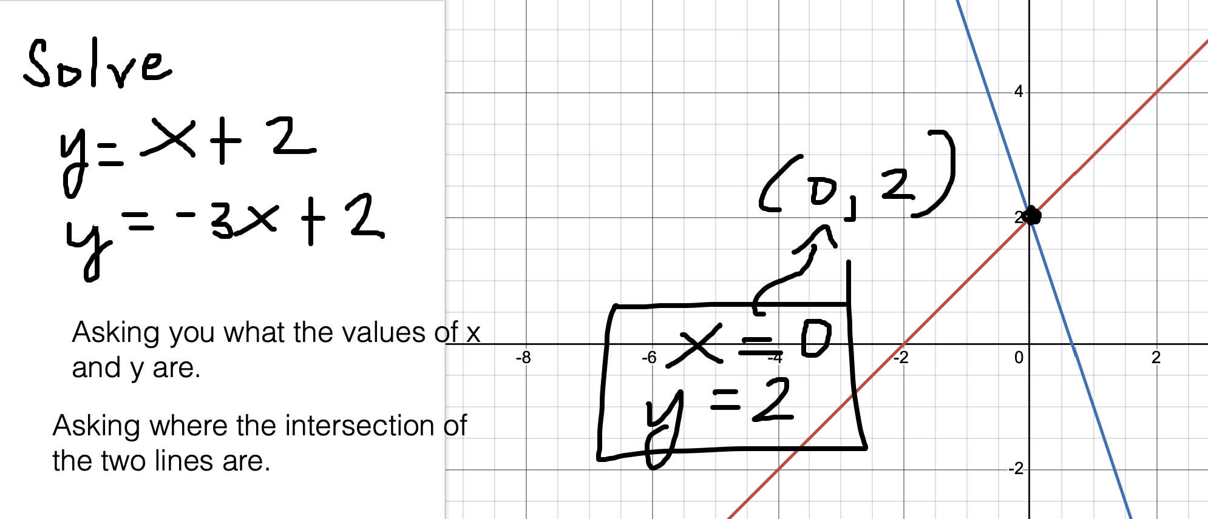

Solve:
x + 3y = 0
y = 2x + 1
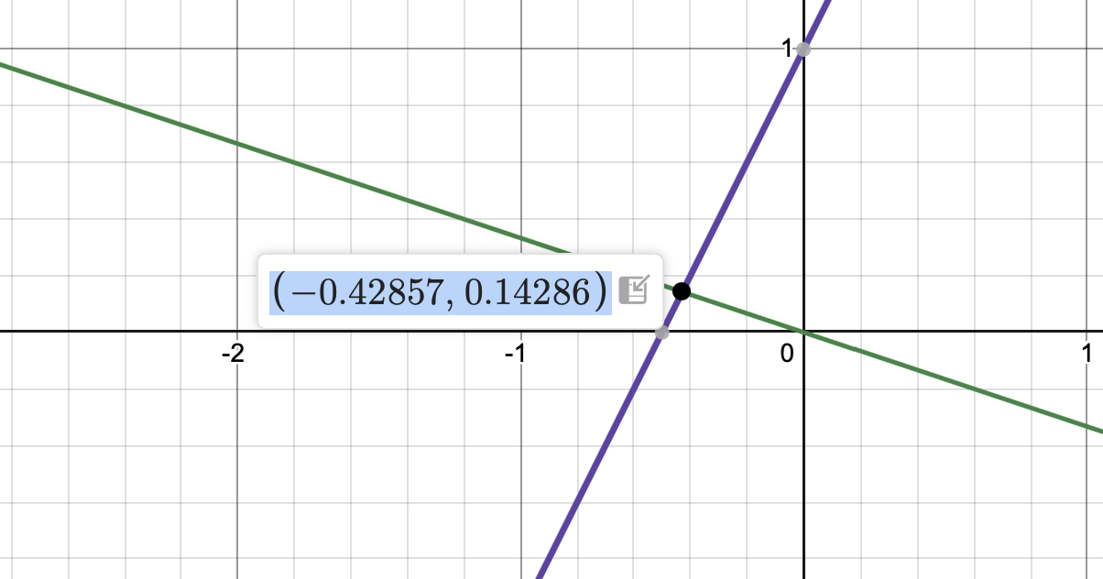
x = -0.429, y = 0.143

Graph and find the intersection point.

Systems of Equations in Two Variables

A linear equation in two variables can be written in the form ax + by = k, where a, b, and k are constants, and a and b are not equal to 0.
A pair of equations is called a system of linear equations because they involve solving more than one linear equation at once.
A solution to a system of equations consists of an x-value and a y-value that satisfy both equations simultaneously. The set of all solutions is called the solution set.
Graphically, these solutions correspond to the intersection(s) of the lines.
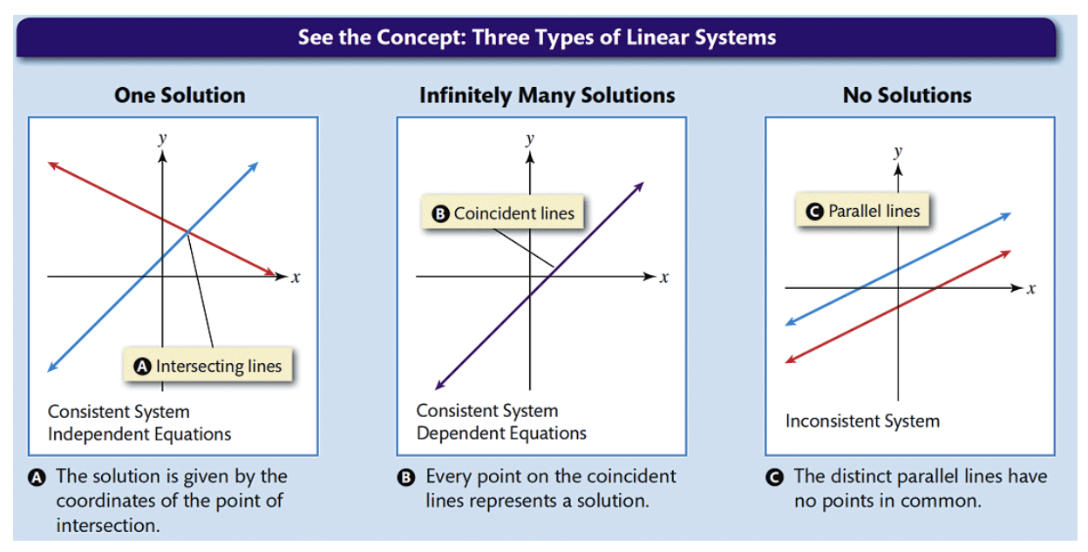

Consistent system just means there is a solution (one, or infinitely many)
Inconsistent system (a system without a solution)

Recognizing Types of Linear Systems
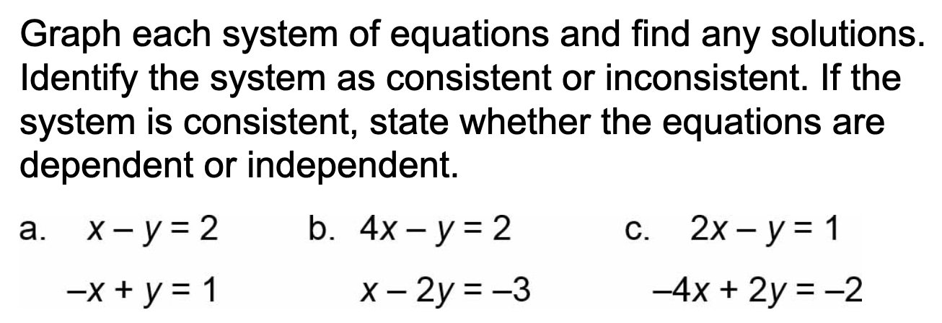

Part (a), the lines do not intersect. There is no solution. The system is inconsistent.
Part (b), the lines intersect. There is 1 solution. The system is consistent (there is a solution). The system is independent (1 solution).
Part (b), the lines are coincident. There are infinitely many solutions (there is a solution). The system is consistent. Since there are infinitely many solutions, the system is dependent (infinitely many solutions).

Substitution Method
The substitution method involves solving one equation for one variable and substituting that into the other equation.

- Solve one equation for one variable.
Choose one of the equations in the system and solve it for either xx or yy (or any other variable that may appear).
- Substitute the expression into the other equation.
Take the expression you found for the variable and substitute it into the other equation in place of that variable.
- Solve the resulting equation.
After substitution, you’ll have a single equation with only one variable. Solve this equation for the remaining variable.
- Substitute the value back to find the other variable.
Once you have the value of one variable, substitute it back into one of the original equations to find the value of the other variable.
- Check your solution.
After finding the values of both variables, substitute them back into both original equations to verify that the solution satisfies both.

Example. Solve using the substitution method.
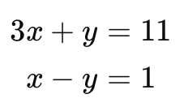

Step 1. Pick an equation and solve for one variable.
3x + y = 11
Subtracting 3x from both sides, y = 11-3x

Step 2.
x - y = 1
x - (11-3x) = 1

Step 3. Solve the equation.
x - 11 + 3x = 1
4x = 12
x = 3

Step 4. Substitute for either equation and solve for the other variable.

y = 11-3x = 11-3(3) = 11-9 = 2
y = 2

The point (3, 2) is the intersection point of the graphs of the two lines.
x = 3 and y = 2

Step 5. Check.

3x + y = 11
3(3) + 2 = 11 (yes, true statement)

x-y=1
3-2=1 (yes, true statement)

The answer checks out.

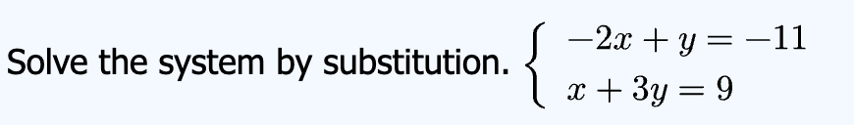

Step 1. Pick an equation and solve for a variable.

-2x + y = -11
+2x +2x

y = -11 + 2x

Step 2. Substitute the expression into the other equation.

x + 3y = 9
x + 3(-11 + 2x) = 9

Step 3. Solve the equation.
x - 33 + 6x = 9
7x = 42
x = 6

Step 4. Substitute x = 6 into any of the equations.

y = -11 + 2x = -11 + 2(6) = 1

The two equations intersect at (6, 1), which is the solution. x = 6 and y = 1.
The system is consistent (there is a solution) and independent (1 unique solution)

Solve:
x + y = 2
x + y = 5

Step 1. Pick an equation and solve for a variable.
x + y = 5
y = 5 - x

Step 2. Substitute the expression into the other equation.
x + y = 2
x + (5-x) = 2

Step 3. Solve the equation.
Solve x + 5 - x = 2.
5 = 2 (false)

When solving for a single equation and you get a false statement, that means that the system has no solution.

Notation: Ø (empty set, null set - a set without anything in it)

Solve:
x+y = 5
2x+2y = 10

y = 5 - x

2x + 2(5-x) = 10

2x + 10 - 2x = 10

10 = 10 (true)

There are infinitely many solutions.

{ (x, y) | x + y = 5 }

Alternative, { (x, y) | 2x + 2y = 10}

In English:

The set of all points (x, y) on the line x + y = 5

The set of all points (x, y) such that x + y = 5

Elimination/Addition Method

The elimination method is another technique used to solve systems of linear equations. The idea is to eliminate one of the variables by adding or subtracting the equations. This method is particularly useful when the coefficients of one of the variables are the same (or can be made the same) in both equations.

- Multiply the equations (if necessary):
If needed, multiply one or both of the equations by a constant to make the coefficients of one of the variables the same in both equations (but with opposite signs).
- Add or subtract the equations:
Add or subtract the equations to eliminate one of the variables. This will give you an equation with only one variable.
- Solve for the remaining variable.
- Substitute the value back:
Once you find the value of one variable, substitute it back into one of the original equations to find the other variable.
- Check the solution:
Finally, check the solution by substituting both values into the original equations.

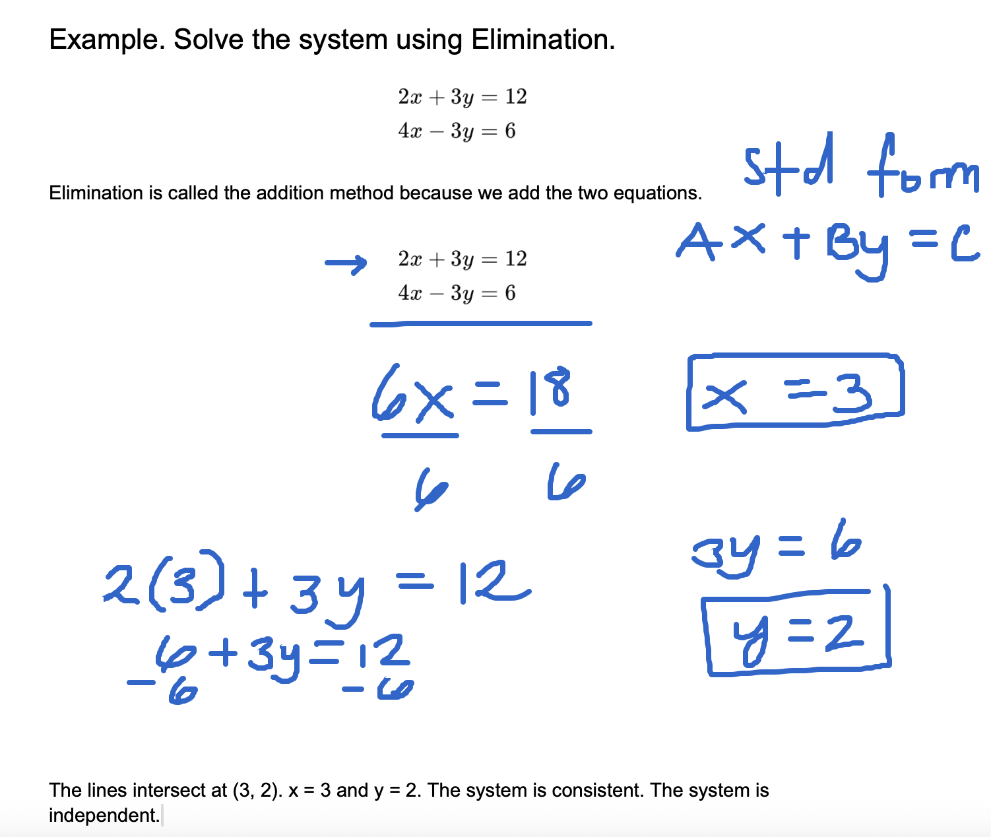

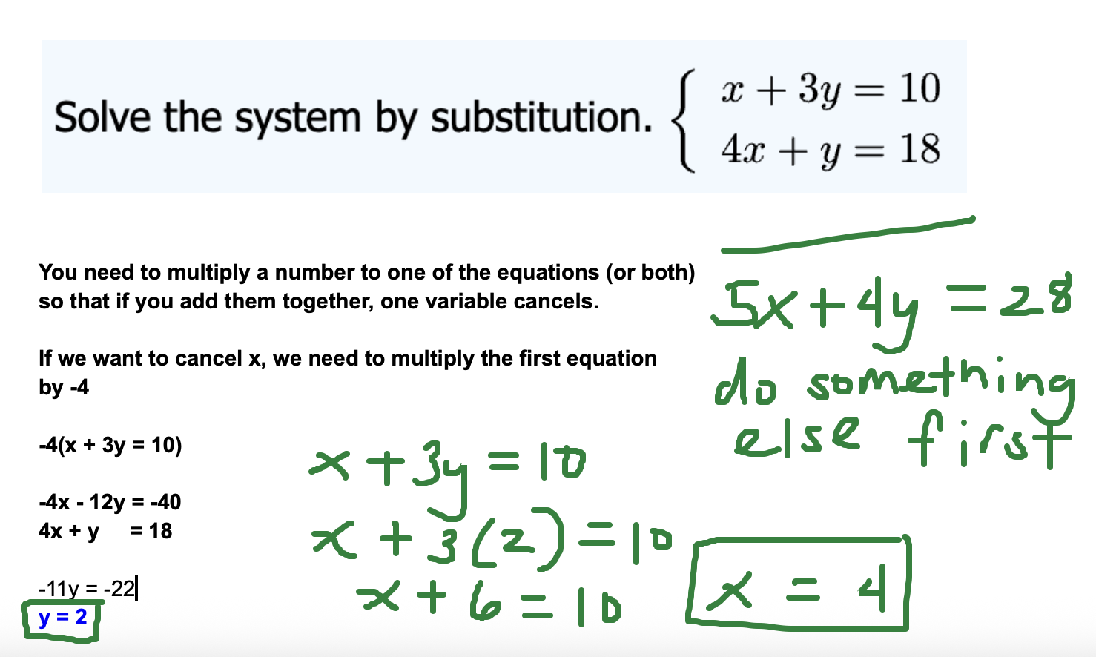

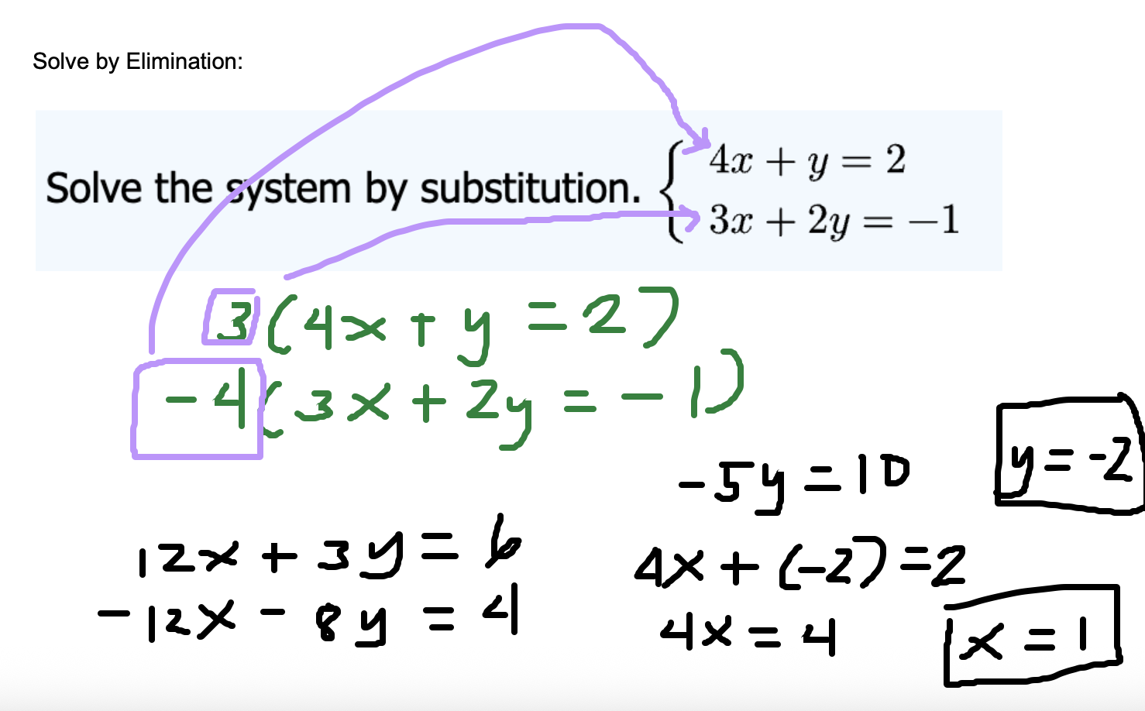

Word Problems

- Find the value of two numbers if their sum is 12 and their difference is 4.

Let's assign x to the first number and y to the second number.
The word sum indicates addition.
The word difference indicates subtraction.

x + y = 12
x - y = 4

Use elimination to solve the above system.

2x = 16
x = 8

8 + y = 12
y = 4

Next time for Practice. I'll send you a video with additional examples.
- The difference between the two numbers is 3. Their sum is 13. Find the numbers.
- Brenda's school is selling tickets to a spring musical. On the first day of ticket sales the school sold 3 senior citizen tickets and 9 child tickets for a total of $75. The school took in $67 on the second day by selling 8 senior citizen tickets and 5 child tickets. What is the price of one senior citizen ticket and one child ticket?
- Matt and Ming are selling fruit for a school fundraiser. Customers can buy small boxes of oranges and large boxes of oranges. Matt sold 3 small boxes of oranges and 14 large boxes of oranges for a total of $203. Ming sold 11 small boxes of oranges and 11 large boxes of oranges for a total of $220. Find the cost of each small box of oranges and one large box of oranges.

